Section A:

- Which ion do acids produce in aqueous solutions?
Tick one box.
H⁺
OH⁻
H⁻

- Which ion do alkalis produce in aqueous solutions?
Tick one box.
H⁺
OH⁻
H⁻

- Add labels to this pH scale to show the pH of acidic, alkaline and neutral solutions.

0 | 1 | 2 | 3 | 4 | 5 | 6 | 7 | 8 | 9 | 10 | 11 | 12 | 13 | 14

- Which colour would Universal Indicator turn when added to an alkaline solution?
Tick one box.
Red/orange
Green
Purple/blue

- Which colour would Universal Indicator turn when added to an acidic solution?
Tick one box.
Red/orange
Green
Purple/blue
Section B

- Lots of different everyday substances can be classified as acids, bases or salts. Car batteries contain sulfuric acid, some cleaning products contain sodium hydroxide and table salt contains sodium chloride.

  - Explain how Universal Indicator could be used to identify each of these substances.

____________________________________________________________________________________
____________________________________________________________________________________
____________________________________________________________________________________
____________________________________________________________________________________
____________________________________________________________________________________
____________________________________________________________________________________

  - Describe another way that the pH of each substance could be measured.

____________________________________________________________________________________
____________________________________________________________________________________

  - Explain the difference between a base and an alkali.

____________________________________________________________________________________
____________________________________________________________________________________

Sodium chloride can be made from a reaction between sodium hydroxide and hydrochloric acid.

  - Name this type of reaction.

____________________________________________________________________________________

  - Write a balanced chemical equation for this reaction.

____________ (aq) + ___________(aq) à __________ (aq) + ____________ (l)

  - What does the state symbol (aq) mean?

____________________________________________________________________________________

  - Describe how the salt could be separated from the other product of this reaction.

____________________________________________________________________________________
____________________________________________________________________________________
____________________________________________________________________________________
____________________________________________________________________________________

  - A scientist wants to make sodium sulfate instead of sodium chloride. Which acid should they use?

____________________________________________________________________________________

  - Determine the chemical formula of sodium sulfate.

____________________________________________________________________________________

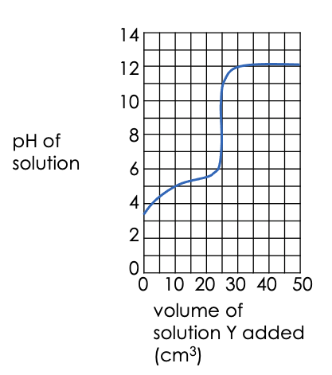
- A student added solution Y to a beaker containing solution X. The graph shows how the pH of the resulting solution changed.

  - What was the pH of solution X before solution Y was added to it?

___________________________________

  - Was solution Y acidic, alkaline or neutral? Explain your answer.
___________________________________
___________________________________
___________________________________
___________________________________
___________________________________
  - What volume of solution Y was needed to completely react with solution X?

____________________________________________________________________________________

- Explain what happens when an acid reacts with an alkali in terms of ions and molecules.

____________________________________________________________________________________
____________________________________________________________________________________
____________________________________________________________________________________
____________________________________________________________________________________
____________________________________________________________________________________
____________________________________________________________________________________

- Complete the word equation for each reaction and write a balanced symbol equation.

- Barium hydroxide + hydrochloric acid →

- Sulfuric acid + sodium hydroxide →

- Lithium hydroxide + nitric acid →

- Calculate the relative formula mass of each of the salts in Q9.

Section C
- Sodium hydroxide reacts with hydrochloric acid.
- What is the alkali in this reaction?
- Write a word equation for this reaction.
- Write a balanced symbol equation for this reaction.
- Write the ionic equation for neutralisation.
- Name the salt produced in this reaction.
- Calculate the relative formula mass of this salt.
- Calculate the percentage by mass of sodium in this salt.
- Compare the physical properties of the elements that make up this salt with the properties of the salt as a compound.
- Identify the type of bonding in this salt.
- Draw a diagram to show how this bonding takes place.

